

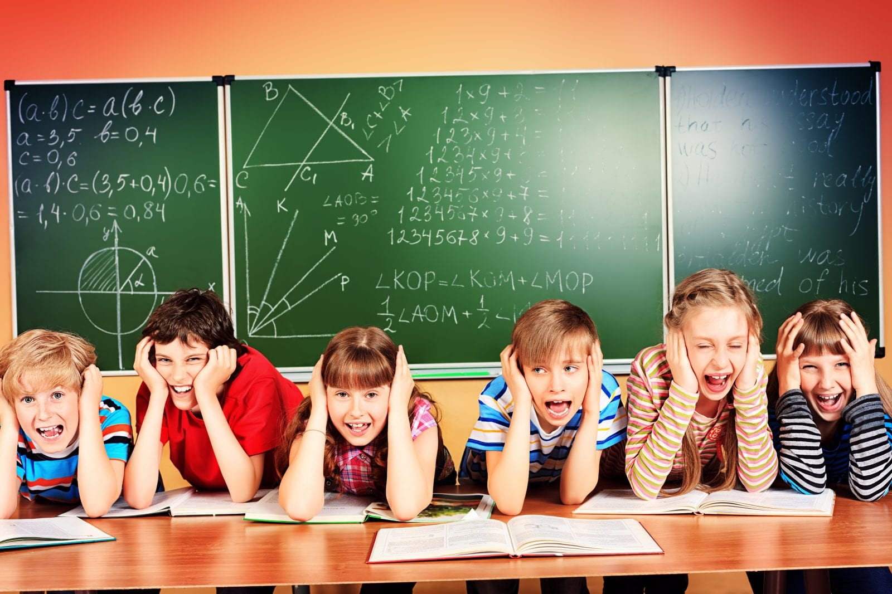

Indian State’s Education Analysis of Literacy Rate and Dropout Rates

Feynn Labs

Bage Aman Shaikh | Machine Learning Intern | 25th May,2022

# Abstract

Comparatively to other Indian states, Kerala has a high literacy rate and human development. While education affects human development in many ways, it is considered to be one of the most important factors. Human Development Index methodology continues to include literacy as a core component. The role of education in reducing poverty and promoting equity, fairness, and social justice has long been recognized. In this study, we investigate factors contributing to the high dropout rate and evaluate the success of literacy programs. In this study, it was shown that education levels in India may influence governmental actions and shape the future of India.

# Introduction

A constitutional commitment in India mandates free and compulsory education for all children up to the age of fourteen. Additionally, the Right of Children to Free and Compulsory Education Act of 2009 gives every child aged six to fourteen years the right to free and compulsory education until completing elementary education. Education in India is universalized through universal access, universal enrollment, universal retention, and universal quality of education, all of which are vital to the universalization of elementary education. Out of these factors, universal access is by far the most critical in assessing the quality of both Primary and Upper Primary education.

Most tribal communities have an educational level below primary school. Several interrelated factors have contributed to low enrollments and high dropout rates, including state infrastructure, poverty, socioeconomic factors, cultural and familial influences, and individual factors. Infrastructural problems include a lack of schools, difficulty accessing those that do exist, a lack of study materials in students' native languages, as well as insufficient teacher support. As an example, Reference identifies dialect usage and socioeconomic status as factors responsible for low enrollment rates. Research has shown that mother tongue language should be used as the medium of instruction in early childhood due to language barriers in educational materials and among non-tribal teachers.

## Indian Education system: The Present Pyramidal structure

The Indian education system can broadly be considered as a pyramidal structure:

1. **Pre-primary level:** 5-6 years of age.
2. **Primary (elementary) level:** 6-14 years of age. Elementary-level education is guaranteed by our constitution under**Article 21 A**. For this level, the government has introduced **Sarva Shiksha Abhiyan (SSA)**under the **Right To Education (RTE) Act.**
3. **Secondary level:** Age group between 14-18. For this level, the government has extended SSA to secondary education in the form of the **Rashtriya Madhyamik Shiksha Abhiyan**.
4. **Higher education:** generally, of three levels: UG→ PG→ MPhil/PhD. To cater to the requirements of higher education, the government has introduced **Rashtriya Uchhattar Shiksha Abhiyan** (RUSA).

## TECHNOLOGY IN EDUCATION

* Technology plays a significant role in:
* Improving the classroom process of teaching, learning and evaluation
* Aiding teacher training.
* Improving access to education.
* Improving the overall planning, administration and management of the entire education system.
* **National Repository on Educational Data**: All records pertaining to institutions, professors, and students are preserved digitally.
* Copyright-free instructional resources in many languages can be found in a single online digital repository.

# Material and Method

This paper will examine how the literacy rates in Indian states differ. I'll be using this data from Kaggle, which contains census data on the literacy rate in various Indian states, as well as education indicators such as the number of teachers, schools, and so on, for Indian states and Union territories in 2015–16.

I'll try to provide detailed answers to the following three questions:

1. Which states have the highest and lowest rates of literacy?
2. What distinguishes the top three states from the bottom three, and what factors can the bottom three states work on to improve their literacy rate?
3. Which class has the highest dropout rate?

The last point above is not a question, but I figured it could be used to predict the literacy rate based on education indicators each year because the literacy rate is only calculated once every ten years (during the census), but education indicators are calculated every year. As a result, it is easier to understand how the literacy rate changes as educational indicators change.

# Which states have the highest and the lowest literacy rates?

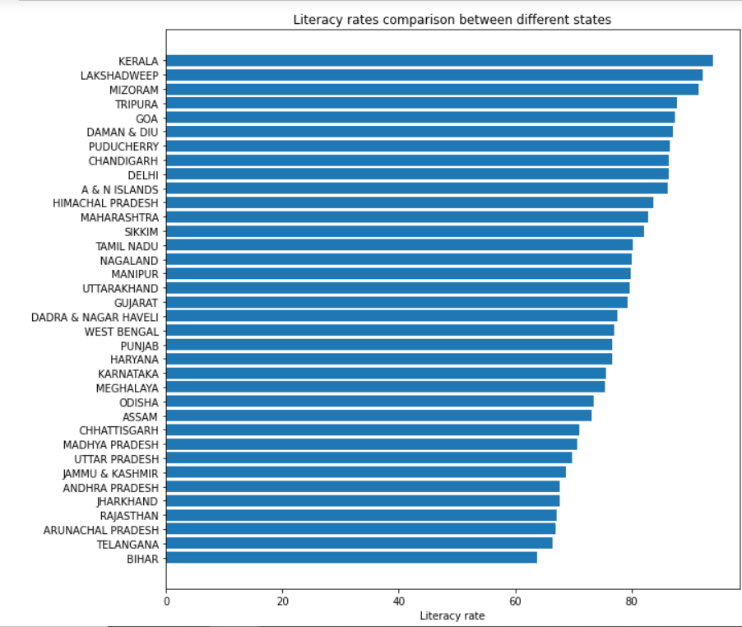

* Kerala has the highest literacy rate (93.91%). Lakshadweep comes in second with 92.28 percent and Mizoram comes in third with 91.58 percent.
* Bihar has the lowest literacy rate (63.82%), followed by Telangana (66.46%) and Arunachal Pradesh (66.95%).
* There is a significant disparity of approximately 30% between Kerala and Bihar.

## Another item to look at is how these states rank in terms of male and female literacy rates.

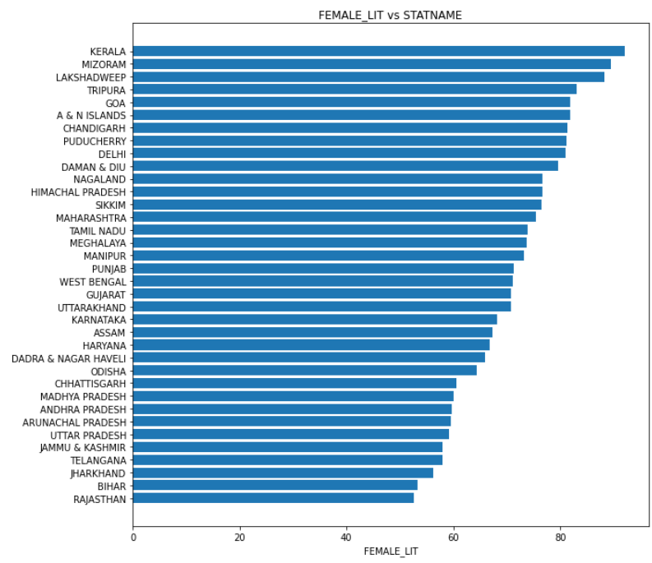

* The 'female literacy rate in different states' graph is now available. Kerala maintains its position with an extremely high 91.98 percent. Lakshadweep and Mizoram have shifted ranks, with female literacy rates of 89.40 and 88.25, respectively.
* Rajasthan, Bihar, and Jharkhand, on the other hand, have female literacy percentages of 52.66, 53.33, and 56.21, respectively.
* What's important to look at here is the difference between a state's total literacy rate and its female literacy rate. Particularly at the top and bottom. The disparity between the poorest three states is 10–14 percent, whereas the difference between the top three states is roughly 2–4 percent.

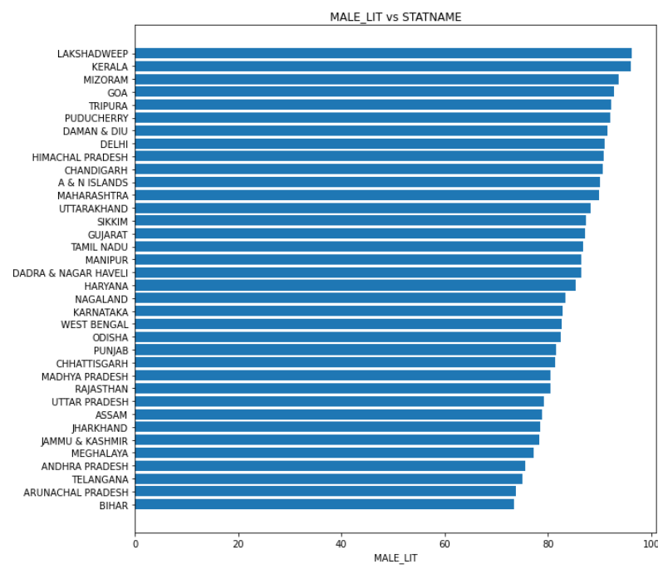

* The 'male literacy rate in different states' graph is now available.
* Again, Lakshadweep, Kerala, and Mizoram have the highest male literacy rates, while Bihar, Arunachal Pradesh, and Telangana have the lowest.
* Bihar appears to need to improve on both male and female literacy rates equally, as both are extremely low.
* We discover two or three highly interesting facts after additional investigation:
* There is very little difference in male and female literacy rates in the North-Eastern states. Meghalaya has the smallest disparity, at 3.39 percent.
* At 27.85, Rajasthan has the greatest disparity between male and female literacy rates. That's a lot of work!

You might be interested in this graph, which compares male and female literacy rates between states and U.Ts:

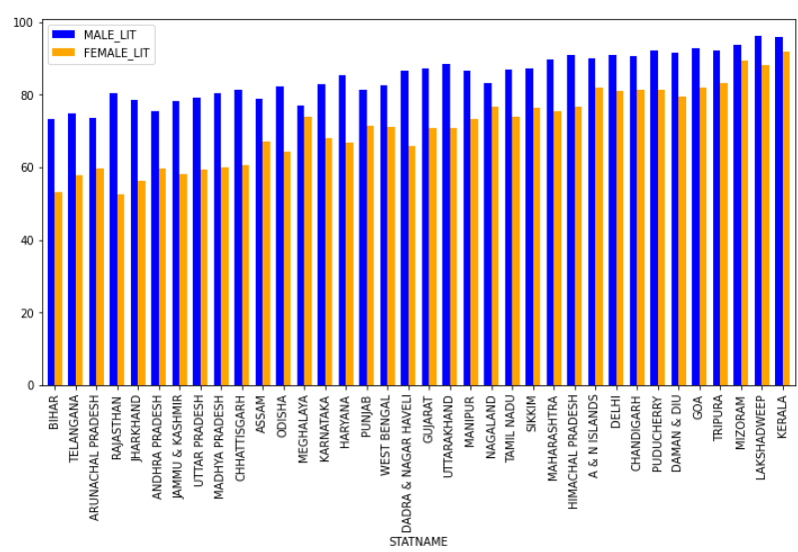Male and Female Literacy rates

# What distinguishes the top three states from the bottom three, and what elements can the lower three states focus on to improve their literacy rate?

* Kerala, Lakshadweep, and Mizoram are our top three states, whereas Bihar, Arunachal Pradesh, and Rajasthan are our lowest three.
* (Telangana was excluded because the state was just founded and there was little prior data on it.)
* The factors that I discovered to be distinguishing the top three and bottom three states were as follows:

### Male and female literacy rates differ

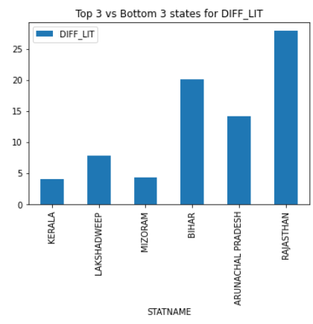

Difference in Male and Female Literacy rates

As previously stated, the disparity between male and female literacy rates impacts the overall literacy rate. The gap was significant for our bottom three states, particularly Rajasthan. Our top three states had the smallest average difference between male and female literacy rates, with Lakshadweep having the most disparity.

### Population Distribution in Cities and Rural Areas

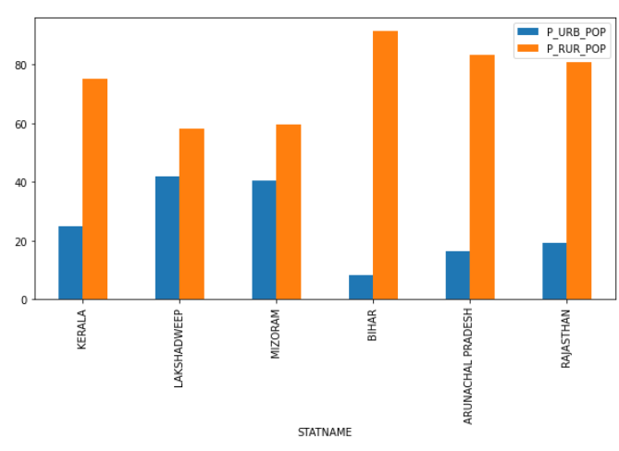Proportion of Rural and Urban Population

Here we have a fairly evident yet significant component that distinguishes our top three and bottom three states. The disparity between rural and urban populations is substantially greater in the bottom three. The rural population is larger in all states, but especially in Bihar, where the disparity is significant. However, when compared to Mizoram and Lakshadweep, Kerala appears to be an exception.

### Comparing the percentage of different types of Primary schools

We can also look at the various types of schools in these states. It is possible that states with a high literacy rate have more private schools than public schools.

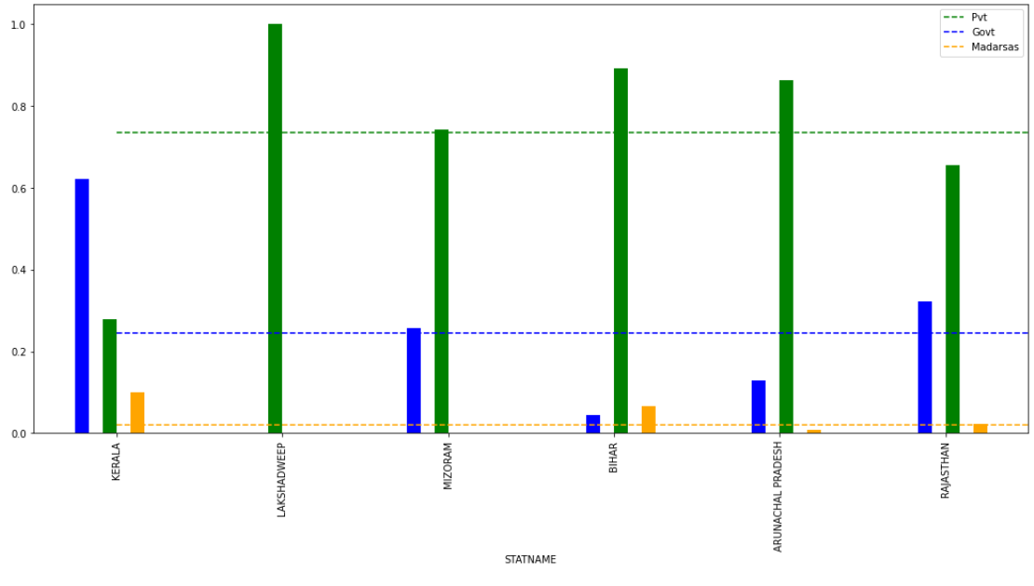

Different types of primary school

We can clearly see the following from here:

* Lakshadweep exclusively has government schools.
* Kerala has the greatest proportion of private schools in total schools and is the only state with more private schools than public schools. It also has an unusually large number of Madrassa, and the number of government schools is significantly lower than the national average.
* Bihar and Arunachal Pradesh have far fewer private schools than government schools. Their percentage of government schools is higher than the national average.
* Rajasthan has approximately 35% private schools, which is more than the number of government schools.
* All of this simply demonstrates that the proportion of private and public schools is unrelated to the literacy rate.

### Dropout rate from Primary to Secondary, i.e., 8th class to 9th class

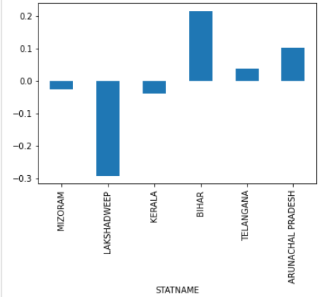

Dropout rates from class 8th to 9th

We believe that the dropout rate from 8th to 9th grades is an essential factor in distinguishing between the top three and bottom three states. It's an apparent cause, but I had no idea there would be such a big difference. The top three states have more admissions in 9th grade than they had in 8th, whereas the bottom three have the opposite trend. This is especially true for Lakshadweep, Bihar, and Andhra Pradesh.

As a result, the following are the important insights from this analysis:

* States can aim to raise female literacy rates by making it safer for girls to travel, establishing girl-only schools with female teachers, offering special incentives to families that enroll their girl child in school, and so on.
* People who live in rural locations have extremely different lives from those who live in urban areas. In rural areas, there is less motivation to attend school because many people pursue their parent's career or company. In addition, children are frequently forced to miss school in order to labor on the farm. The state should provide greater incentives to ensure that youngsters from rural homes complete their education.
* Dropout rates from 8th to 9th grades should be reduced, and plans should be developed to ensure that this rate falls. The causes of high dropout rate should be investigated and addressed.

# Which class is the dropout rate maximum in?

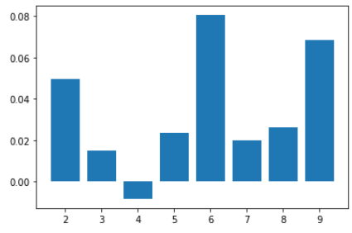

According to the graph, the dropout rate was highest in the sixth grade, followed by the ninth and second grades. Class 4 had a negative dropout rate, which means that more students enrolled and fewer dropped out when going from class 3 to class 4, which is fantastic news!

The dropout rate for fifth and sixth grades was quite high, at 8.5 percent. One reason for this could be that when a child reaches the fifth grade, he is usually old enough to perform a lot of other work as well. His parents may require him to assist them on the farm or in their business in order for him to begin earning money. This is a major issue, particularly in rural India. A further step could be to examine dropout rates between rural and urban schools.

# Discussion And Conclusion

Education and skill development play a significant role in the greater domain of human capital. The outcomes of these policies can be described as mixed. There is still much room for advancement. In India, there are numerous government projects aimed at each level of the education system. The Higher Education System is receiving more attention these days. The present Indian education system is in desperate need of reform. The draught New Education Policy (NEP) is the ideal time to reflect on India's previous history, successes, and concerns, and to map out a visionary education strategy for the twenty-first century.

To review, we began with a comparison of literacy rates in India's various states and union territories. We also analyzed the male and female literacy rates in these states and discovered a significant disparity in the states with a low overall literacy rate. Kerala, Lakshadweep, and Mizoram were the top three states, while Bihar, Telangana, and Arunachal Pradesh were the lowest three.

The disparity in male and female literacy rates, rural population proportion, and dropout rates from 8th to 9th grade then had a significant influence in separating the top three and bottom three states.

Finally, the dropout rates in various classes were investigated, and while the dropout rate in 6th grade was extremely high, more students enrolled in class 4 than dropped out.

The literacy rate in India has been increasing, but there are several critical challenges that must be addressed urgently in order to enhance the state of education in India. This is not simply the government's responsibility; it is the responsibility of everyone in the country. In the future, I hope to see statistics that depict a far better India. In the top three states, we will launch an edtech app that will benefit our bottom line.